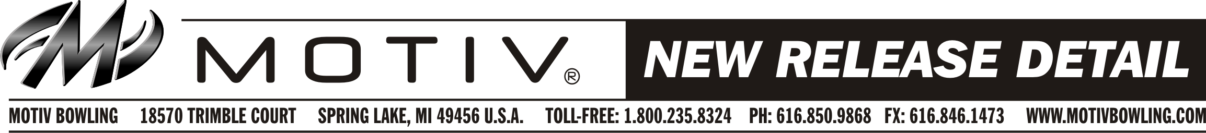
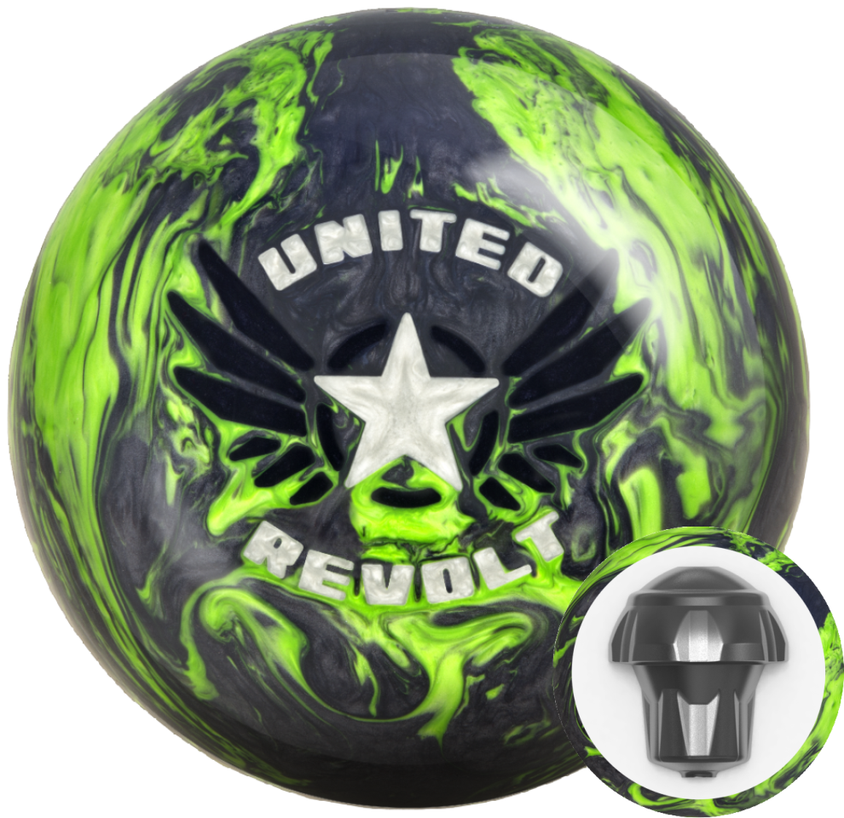

Ball Name: United Revolt
WWRD: March 15, 2017
MAP: $153.95

- Performance: Medium-Heavy Oil
- Weight Range: 12# - 16#
- Inner Core: Vanquish™
- Cover stock: Helix™ HFP Reactive – NEW!
- Finish: 5000 Grit LSP
- 15# RG: 2.47; Diff: .056
- Cover Color: Gray Prl/Lime Prl
- NeoMark™: Black Prl/Silver Prl

KEY SELLING POINTS
- The United Revolt is the first pearl ever offered by MOTIV in the Revolt line and it delivers impressive performance on medium-heavy oil. Utilizing new Helix HFP Reactive technology for the cover and the low RG Vanquish core, the United Revolt provides length yet reads the oil transition incredibly well to give bowlers a strong backend motion that is highly consistent.
- The new Helix HFP (High Friction Pearl) Reactive cover stock is specifically engineered to compliment the Vanquish core and give the United Revolt outstanding motion down lane with devastating continuation. To provide more length and a faster response to friction, the pearl shell is tuned with a 5000 Grit LSP finish.
- The Vanquish core continues to be used in the Revolt line for medium-heavy oil because it has a low RG and enormous differential. The 15# model has a 2.47 RG and .056 differential. This enables the United Revolt to provide plenty of track flare and easy revs, which create more friction and hook potential.
- The United Revolt is not only a great compliment to the Primal Fear, but is also the perfect ball to move down to when the Trident begins to produce too much friction.

