
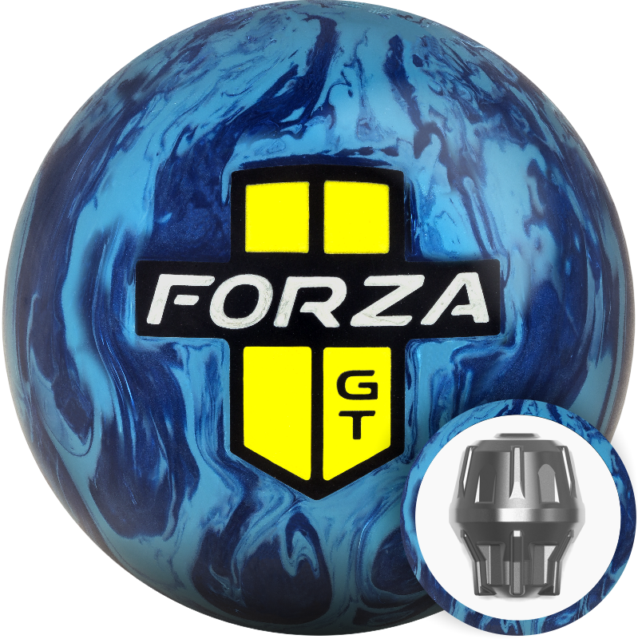
Ball Name: Forza™ GT
MAP: $136.95

- Performance: Medium Oil
- WWRD: July 13, 2016
- Weight Range: 12# - 16#
- Inner Core: Torx™
- Cover: Helix™ HR (Hybrid Reactive)
- Finish: 4000 Grit LSS
- 15# RG: 2.50; Diff: .051
- Cover Color: Two-Tone Blue
- NeoMark™ Color: Black/Yellow Pearl

KEY SELLING POINTS
- The Forza GT hybrid is the next step in the evolution of the MOTIV® product line. Combining the control of the original Forza with the continuation and hitting power of a pearl, the Forza GT provides easy length with incredible consistency down lane.
- The new Helix™ HR (Hybrid Reactive) cover stock provides the Forza GT with the proper amount of traction for medium oil conditions. Because it has the impressive ability to produce both length and control, it is a crucial piece for any competitive bowler looking to excel on challenging patterns where angular balls react too quickly and smooth pieces expend too much energy and lose continuation. Tuned with a 4000 Grit LSS finish, the Helix HR shell provides the Forza GT with the perfect balance.
- As with previous Forza balls, the GT edition utilizes the proven Torx™ weight block. The 15# model produces a 2.50 RG and .051 differential, which makes the Forza GT incredibly versatile.
- Bowlers who loved the length of the Forza Redline will have a smoother compliment to it with the Forza GT, while those who loved the original Forza on fresh oil will be able to use this new version when the oil in the front of the lane breaks down.

