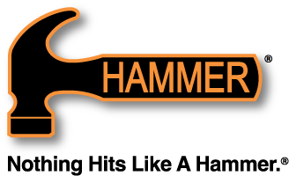

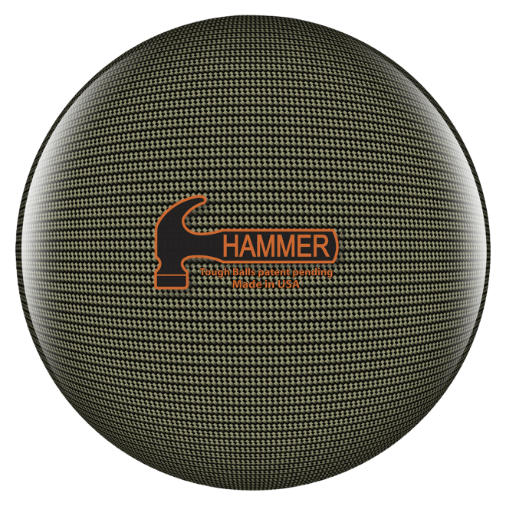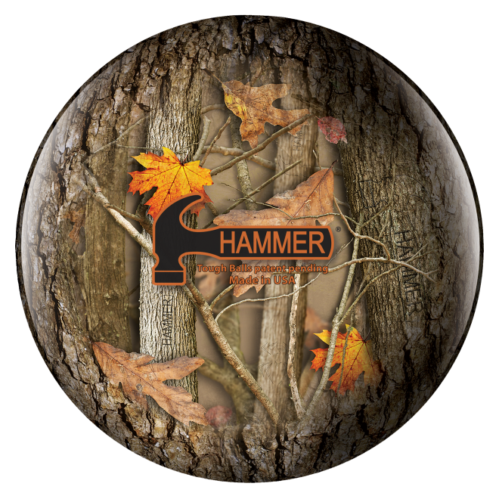

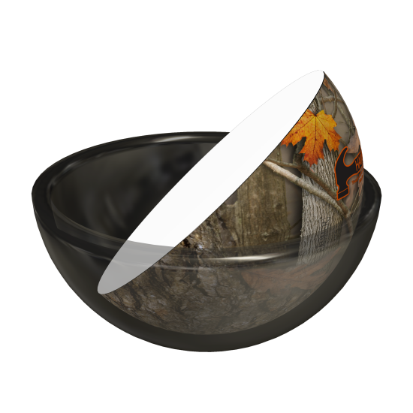
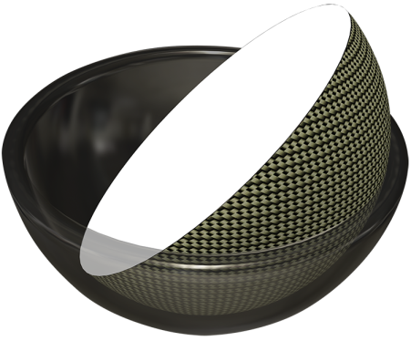

This new line of TOUGH balls goes through the most unique process ever brought to a bowling ball. We dip the outer core in a material that overlays an image on the core in a process called Hydro-Grapics. This process allows Hammer to add incredibly unique images to the core to give bowlers the TOUGHEST looking polyester balls ever created; this is a process that is patent pending.

The first TOUGH ball is called Hammerflage, it’s Hammer’s version of camouflage. There is an incredible amount of detail invested into the image; you’ll be amazed at what you find. The second version a Carbon-Fiber print that makes it hard to believe that the ball isn’t actually made out of Carbon-Fiber, the intricacy will blow you away!
Available Weights: 8, 10, 12, 14-16
Pancake weight block.

