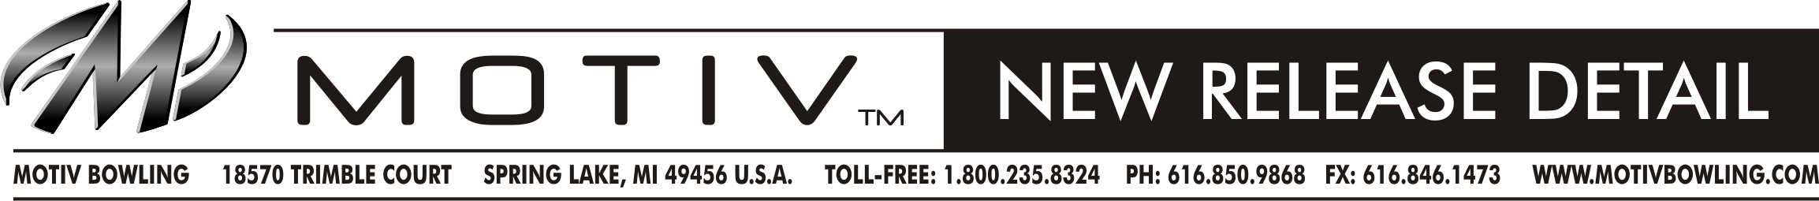
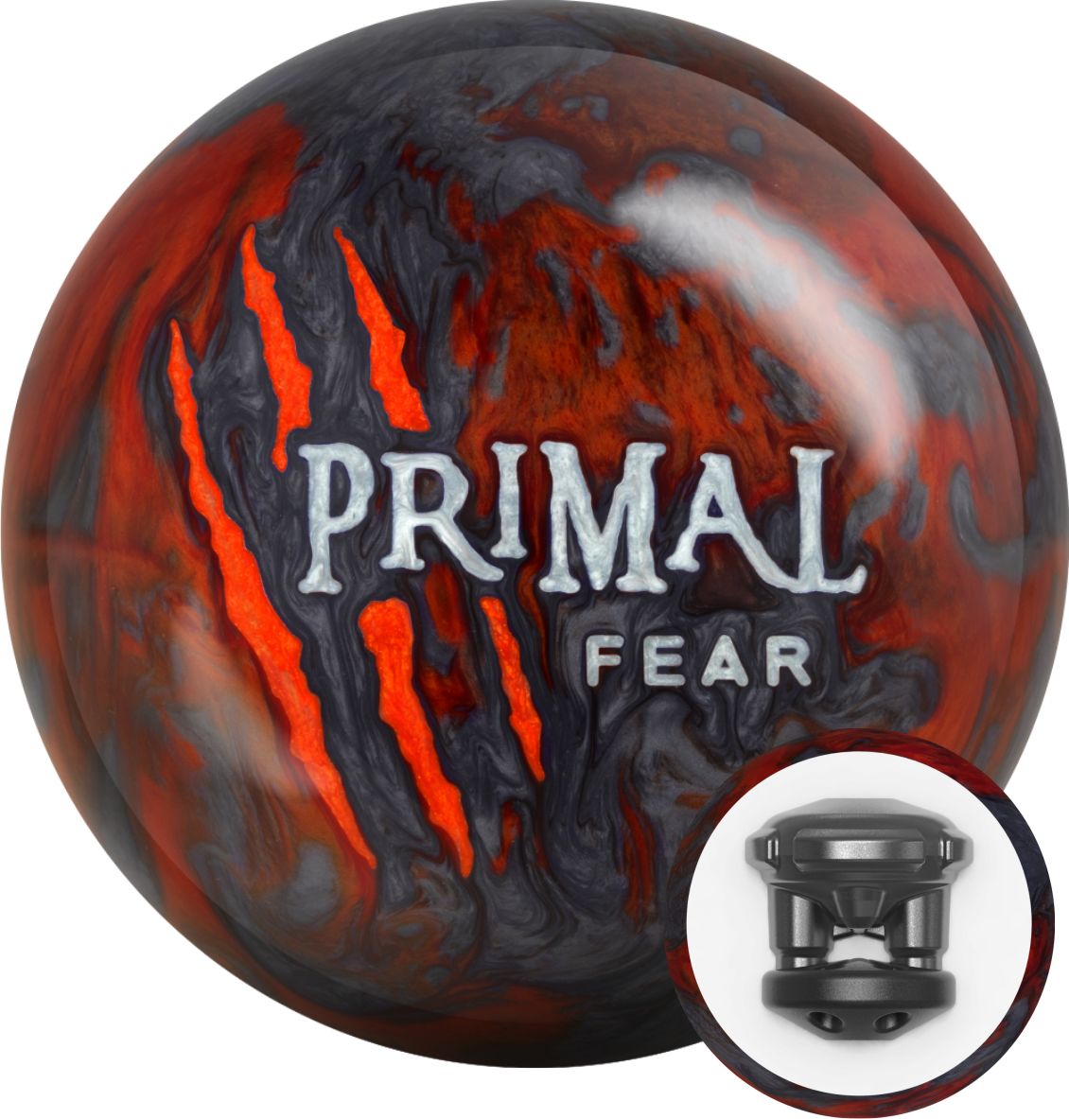
Ball Name: Primal Fear
MAP: $159.95

- Performance: Medium-Heavy Oil
- WWRD: October 31, 2016
- Weight Range: 12# - 16#
- Inner Core: Impulse™ V2
- Cover: Voracity™ Pearl Reactive
- Finish: 5000 Grit LSP
- 15# RG: 2.55; Diff: .050
- Cover Color: Orange Prl/Charcoal Prl
- NeoMark™ Color: Orange Prl/Silver Prl

KEY SELLING POINTS

- Continuing with the intimidating performance standards set by the Primal Rage and Primal Rage Remix, the Primal Fear is an angular monster built for medium-heavy oil patterns.
- The proven Impulse™ V2 core at the center of the Primal Fear remains one of the most advanced in the industry. The dynamic dual-density design provides a strong skid-flip reaction and backend propulsion that is incredibly impressive.
- Integrating this core technology with new Voracity™ Pearl Reactive cover stock, the Primal Fear delivers more power and continuation than ever before. Voracity™ is the most aggressive and most angular pearl cover ever used in the Primal™ line. The Primal Fear is tuned with a 5000 Grit LSP finish.
- Fans of the Primal Rage will appreciate the ability of the Primal Fear to combat higher viscosity oils and higher volume patterns. Bowlers who have thrown the Remix edition will find that the Primal Fear is cleaner down the lane with improved continuation.



